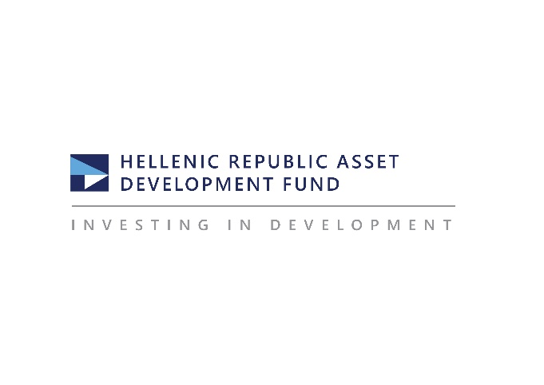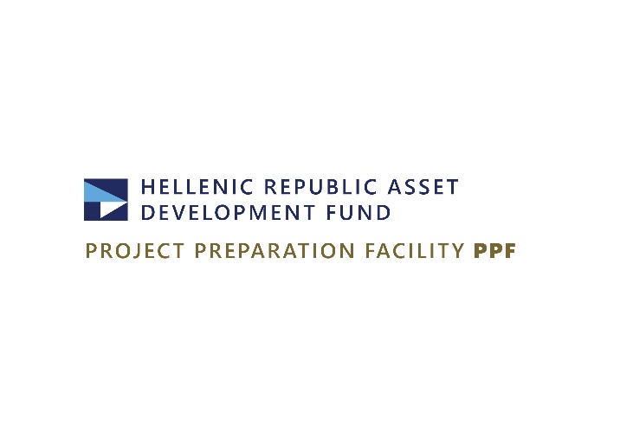
Athens, May 16, 2024
PRESS RELEASE
HRAD: The Alexandroupolis Port Authority enters a new phase of development
Signing of the contract for the project regarding the connection of the new commercial pier of the port with the new Ring Road - Presentation of the main pillars of the Business Plan
At an event held today, Thursday May 16, 2024 in Alexandroupolis, in the presence of the Minister of Maritime Affairs and Insular Policy, Christos Stylianides, the Secretary General of Maritime Affairs and Ports, Evangelos Kyriazopoulos, the CEO of HRADF, Dimitris Politis and the Executive Director of HRADF, Panagiotis Stampoulidis, a 4-million euros contract was signed for the project involving the connection of the new commercial pier of the port of Alexandroupolis with the new Ring Road. In addition, the main strategic pillars of the Business Plan for the Alexandroupolis Port Authority (APA S.A.) were presented.
The signing ceremony was attended by, among others, the Regional Governor of Eastern Macedonia & Thrace, Christodoulos Topsidis, members of parliament from the constituency of Evros, the Mayor of Alexandroupolis, Yiannis Zamboukis, the Managing Director of APA S.A., Konstantinos Chatzikonstantinou, and representatives of the port users.
The project for the connection of the new commercial pier of the port of Alexandroupolis with the new Ring Road involves the construction of a 1.5 kilometers long road within the land area of the port. The project is part of a broader strategic plan, amounting to 18.2 million euros, for upgrading of the infrastructure of APA S.A., which also includes the restoration of depths (dredging) in the port basin and the shipping channel. The contract for the road connection project, worth 4 million euros, was signed by the Minister of Maritime Affairs and Insular Policy and the President and CEO of the contractor company TEKAL S.A., Panagiotis Psaltakos.
The Project Preparation Facility (PPF) of HRADF prepared and carried out the tender, acting on behalf of the Ministry of Maritime Affairs and Insular Policy. The road and the dredging projects are included in the National Recovery and Resilience Plan "Greece 2.0" and are funded by the EU – NextGenerationEU.
The new road infrastructure will allow the diversion of commercial traffic of the port to the Egnatia Odos Motorway, through the Alexandroupolis Ring Road, bypassing urban fabric.
At the event, HRADF’s executives presented the main pillars of the Business Plan for the sustainable development of the port. The Plan provides for investments exceeding 70 million euros regarding the procurement of handling equipment for containers and cereals/crops, as well as initiatives for the further upgrading of the port infrastructure to attract shipping traffic that currently transits through the Bosporus Straits and to become competitive with neighboring ports on the Black Sea. In this context, the construction of a new multi-purpose terminal in the eastern part of the port will be examined in order to accommodate further container traffic.
The Minister of Maritime Affairs and Insular Policy, Christos Stylianides, said: “This signing showcases our commitment to sustainable development and to creating an environment in which the younger generation will be be able to work, live and prosper on even better terms. I would like to thank the Fund for this initiative, in cooperation with the management of APA S.A., which will enhance the competitiveness of the port of Alexandroupolis and will support its upgraded geostrategic role as a transit and energy hub in the Balkans and the Eastern Mediterranean”.
HRADF's CEO, Dimitris Politis, said: “HRADF, in its capacity as Port Planning Authority, has put together a comprehensive plan for the sustainable development of the Alexandroupolis Port, which represents a crucial maritime infrastructure of strategic importance. The new development plan for APA S.A. includes a number of investments which aim to substantially upgrade the port facilities in order to respond more effectively to its new role. Our goal is to assume an important role in the regional trade between the Black Sea and the Mediterranean and to establish the port as a commercial and energy hub in the wider region of the Eastern Mediterranean and the Balkans. At the same time, the revision of the Master Plan and the Strategic Environmental Impact Assessment (SEIA) are in progress, which will essentially constitute the Roadmap for the future development of APA and in which the projects we present today will be incorporated. HRADF will continue to contribute to the development of the Greek economy and to the creation of added value for local communities and economies. With our significant know-how in the management and development of port infrastructure, we will intensify our efforts to turn the Greek ports into a powerful tool for sustainable growth”.
The Executive Director of HRADF, Panagiotis Stampoulidis, stated: “Today is a very important day for Alexandroupolis and the area of Evros. With the contribution of the Project Preparation Facility, which prepared and carried out the tender for two important projects, amounting to 18,2 euros, regarding the upgrading of the port, the port of Alexandroupolis enters a new development phase. The project for the connection of the new commercial pier with the new Ring Road will bring significant benefits to the local community and the environment, by creating new jobs, relieving the traffic in the the city and reducing greenhouse gas emissions. We will continue to honor in the best of our capabilities the trust of the State by implementing with efficiency, speed and transparency complex projects of strategic importance which are funded by the Recovery and Resilience Fund”.

Please refer to the Fund's website for more information and updates regarding the Hellenic Republic Asset Development Fund (HRADF).
Information for the Press: Αchilleas Topas, Τel +30 6944902085, Email press@hraf.gr & atopas@hraf.gr

