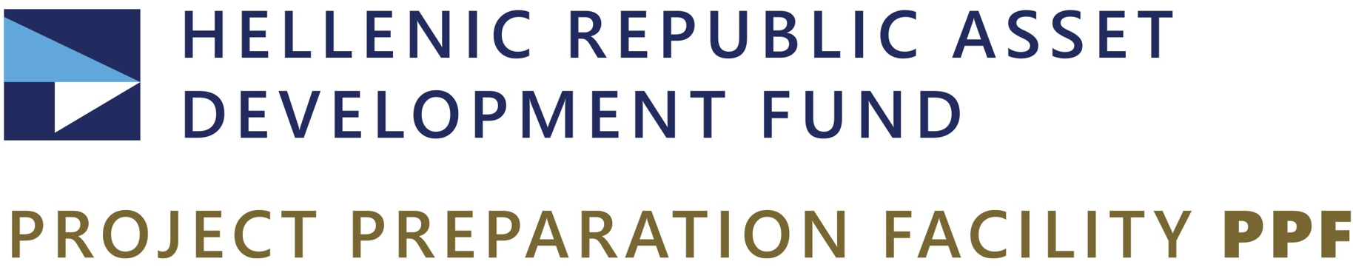
Monday, May 29, 2023
PRESS RELEASE
HRADF: Ongoing tenders worth 144.2 million euros for the upgrade of the infrastructure of the National Health System
New tenders worth EUR 81.8 million euros to be launched imminently
The Hellenic Republic Asset Development Fund, a member company of GROWTHFUND – The National Fund of Greece, announces that since the beginning of the year, the Project Preparation Facility (PPF) of the Fund in cooperation with the Ministry of Health and the competent Health Authorities, has launched a total of 28 tenders with a budget of 144.2 million euros, excluding VAT, for the upgrade of the infrastructure in 28 Hospitals, 57 Health Centers and three (3) Multipurpose Regional Clinics (MRCs) throughout the country.
In particular, the ongoing tenders for the upgrading of hospital facilities have a budget of 63.8 million euros, while those concerning the modernization of Health Centers and MRCs amount to 80.4 million euros. The launch of new tenders by the PPF for the renovation of nine (9) Hospitals, 45 Health Centers and one (1) MRC, with a total budget of 81.8 million euros, is imminent, while in the near future HRADF is expected to publish dozens of new tenders for the upgrade of facilities in more than 40 Hospitals and 50 Health Centers and MRCs, many of which are located on islands and in remote areas. In total, the Fund has so far been assigned to carry out tenders in 96 Hospitals and more than 150 Health Centres and MRCs with a budget of 453 million euros.
The projects concern the addition of new and the upgrade of existing Clinics and Units, the modernization of the Emergency Departments in Hospitals and the energy and operational upgrade of the infrastructure of Health Centers and MRCs. These are interventions with a strong social, environmental and economic footprint, as they will contribute to the radical reform of the infrastructure of the National Health System for the benefit of citizens and the national economy by creating new jobs. They will also contribute to mitigating the effects of the climate crisis and achieving national targets for the reduction of greenhouse gas emissions under the European Green Deal.
The projects are part of the National Recovery and Resilience Plan "Greece 2.0" and are funded by the EU – NextGenerationEU.

Please refer to the Fund's website for more information and updates regarding the Hellenic Republic Asset Development Fund (HRADF).
Information for the Press: Αchilleas Topas, Τel +30 6944902085, Email press@hraf.gr & atopas@hraf.gr
